Terry Yu

CSC 355 Final Project

November 19, 2018

All code answers can be found in their files and here. All answers, such as timings, can be found here

Part I. Database Design (40 points)

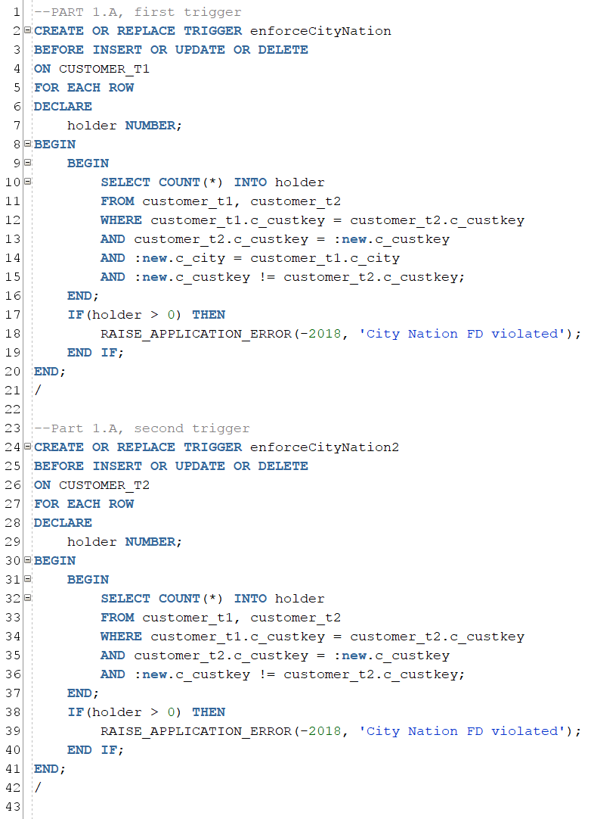

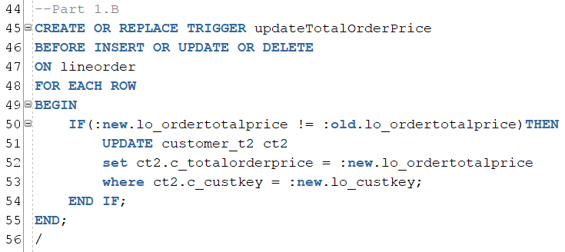

1.C

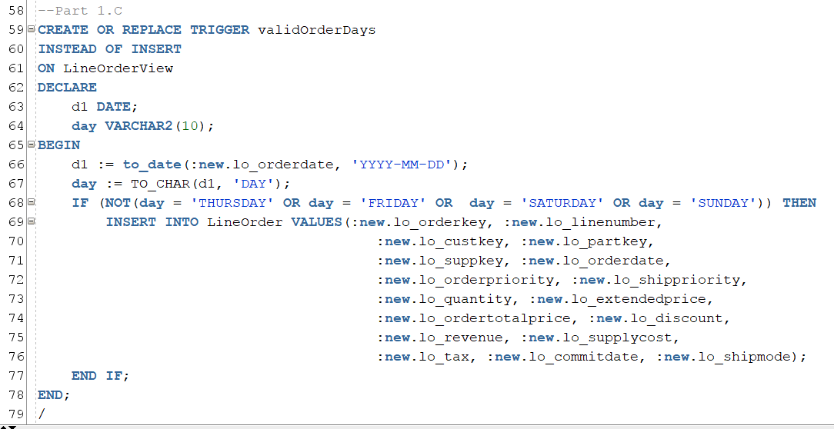

1D.

|  |  |  |
| --- | --- | --- |
| Table Name | Seconds | Count |
| part | 0.149 | 200,000 |
| supplier | 0.017 | 2,000 |
| customer_t1 | 0.038 | 30,000 |
| customer_t2 | 0.049 | 30,000 |
| dwdate | 0.011 | 2,556 |
| lineorder | 2.748 | 5,090,271 |

Part II. SQL (21 points)

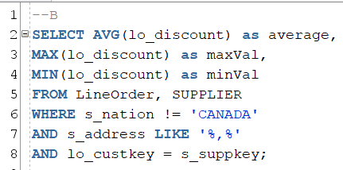

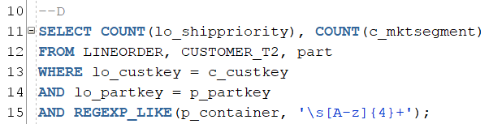

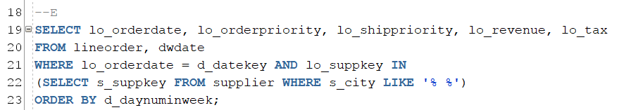

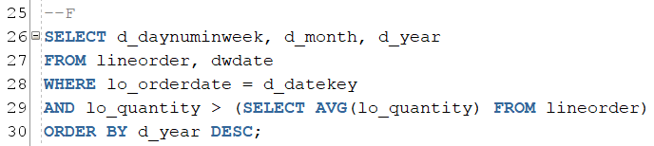

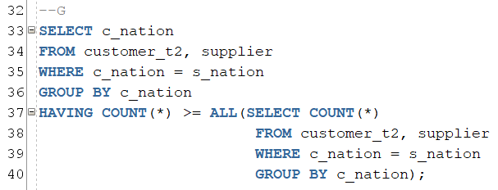

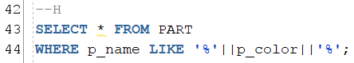

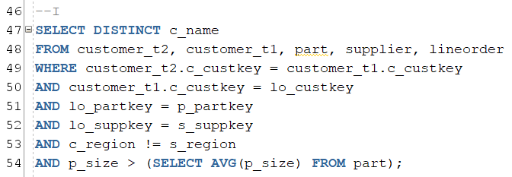

Part III. Query Optimization (39 points)

A1. 11.95 seconds with no index

A2.



A3. 6.225 seconds with index

A4. Yes, the difference was almost half the time. Indexes can speed up the action of accessing records according to the indexing field.

B1.

Query 1: 44.713 seconds

Query 2: 46.064 seconds

B2. No, there was no difference between the two queries because everytime the index file is modified it takes time to perform that process.

